Mr. Visca – AP Calculus AB

Unit 6: Diff EQ and Math Modeling Review Notes

**Slope Fields:**

Here's what the slope field of y' = 2x looks like

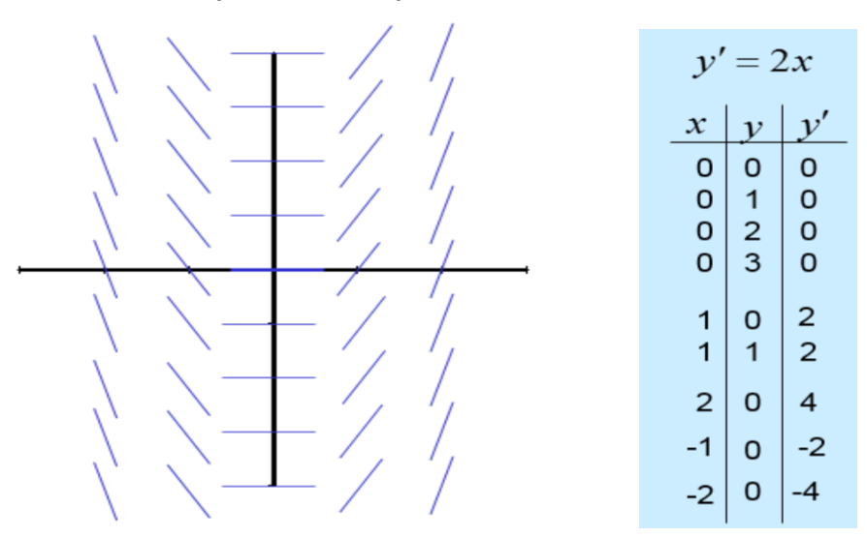

Draw a slope field for: dy/dx = 3x + y

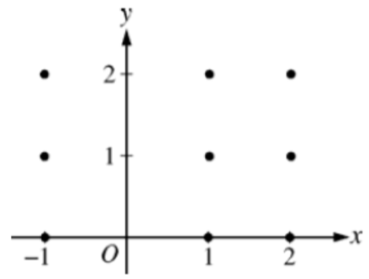

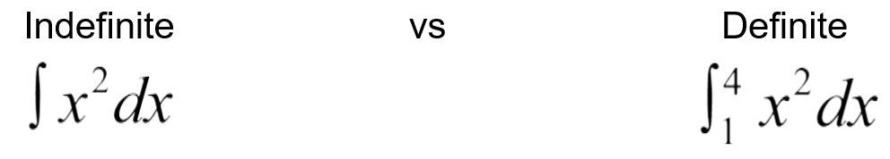**To "C" or not to "C"!**

**More Integrate by U-Sub**

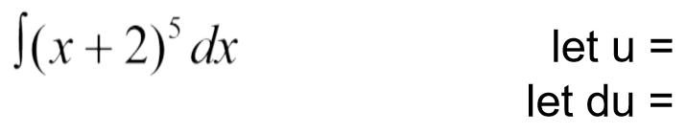

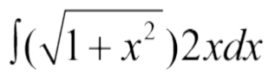

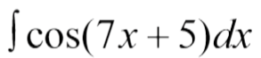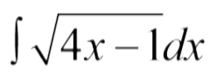

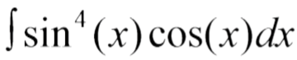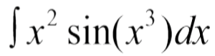

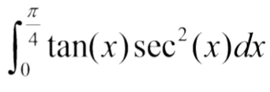**Definite Integral with U-sub…now with bounds!**

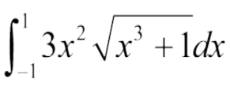

**Separable Differential Equations**

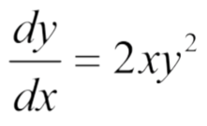

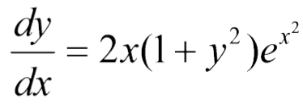

**Unit 6 Review Problems (there is no #8)**

Show all your work!

1.  *dx* =

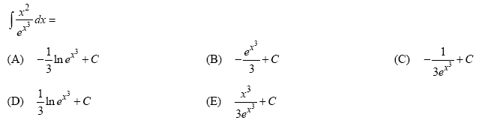

2.

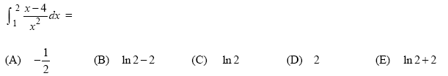

3.

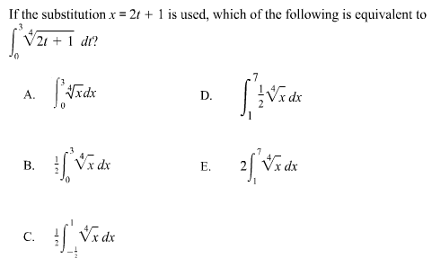4.

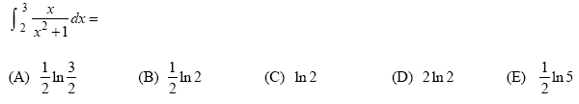

5.

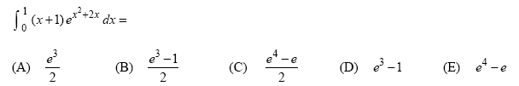6.

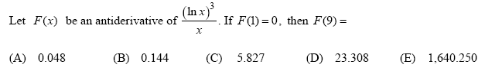

7.

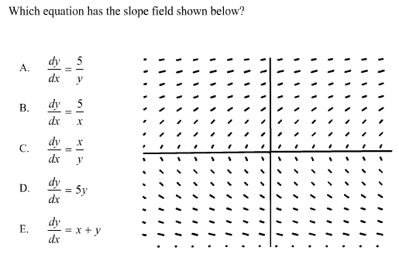9.

(#10 continued on next page)

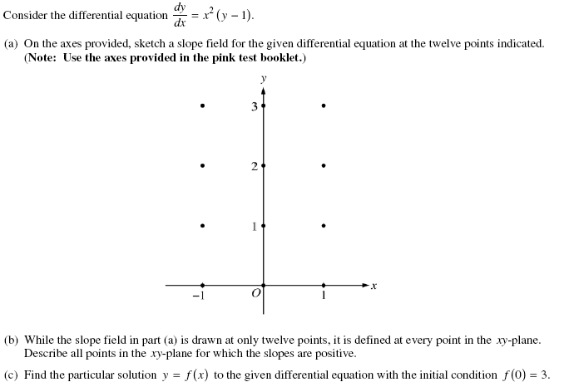10.